Life Under Your Feet: Field Research on Box Turtles

Part I: Our Field Research Site

Scientists often work at field research sites. Field research sites are areas in nature that the scientists have chosen to study to get a better idea of how the natural world works there. They go to these sites and make observations of organisms or measurements of the physical environment. They often return to these sites again and again.

One of the reasons we want to use macroscopes – networks of electronic sensors that record and transmit measurements automatically – for environmental monitoring is so that scientists do not have to go back to field research sites again and again. These return visits take a lot of time, and they can damage the environment at the field research site. If scientists can use a macroscope in a field research site, then the macroscope can send data automatically.

We are testing a macroscope in one of our field research sites at Jug Bay Wetlands Sanctuary in southern Maryland. Our goal in studying this area was to see how the environment affected the nests of Eastern Box Turtles. In Part I, you will explore the environment of this site.

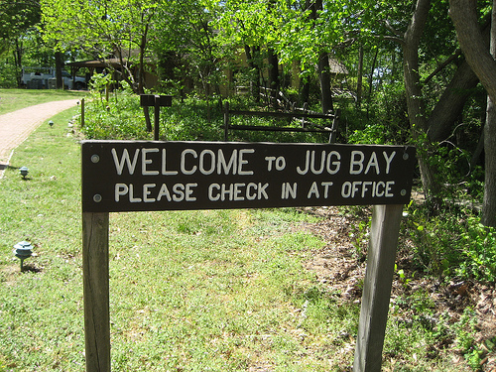

Our Field Research Site: Collect Data

- Go to the Life Under Your Feet website (www.lifeunderyourfeet.org).
- Click on Data in the top navigation menu.
- Click on the Data Mapper link. Wait for the Data Mapper tool to load.
- The Data Mapper will load within the same window. It will look like this:

- Use the map controls to zoom in (+ magnifying glass) on the southernmost of the Network Deployment symbols (). This is Jug Bay Wetlands Sanctuary.

- Zoom in on the area around the deployment area in Jug Bay. The screen should look something like this:
Try zooming in at different levels. Switch back and forth between Aerial (the default view) and Road (a simplified map view) to see how the different views are similar and different.

Our Field Research Site: Analyze Data

- Write down as many observations as you can about the environment at Jug Bay. (Hint: think about what you can learn from both small-scale and large-scale views of the site.)

- Which areas of the field research site are covered by forest? Which areas of the site are covered by grass?

Our Field Research Site: Interpret Data

- What kind of ecosystem is Jug Bay?

- What do you think its major environmental challenges are?

- What data could you collect to understand this research site?

Part II: Our Macroscope in Local Environments at the Research Site

We have deployed a macroscope at our field research site at Jug Bay Wetlands Sanctuary. The macroscope consists of fourteen motes – small computer systems with temperature and soil moisture sensors attached.

We went to the research site in the summer of 2007 and found three turtle nests. We put motes numbered 2, 5, and 6 next to these nests, with soil temperature and moisture sensors at the top and bottom of the nests. We returned in the winter of 2007-08 and found eleven sites where turtles were “overwintering” – burying themselves in the soil for the winter. We put motes numbered 11-14, 29, and 43-45 next to the turtles, and buried sensors above and below each turtle.

The picture on the left below shows a turtle nest in Jug Bay. The picture on the right below shows an overwintering turtle.

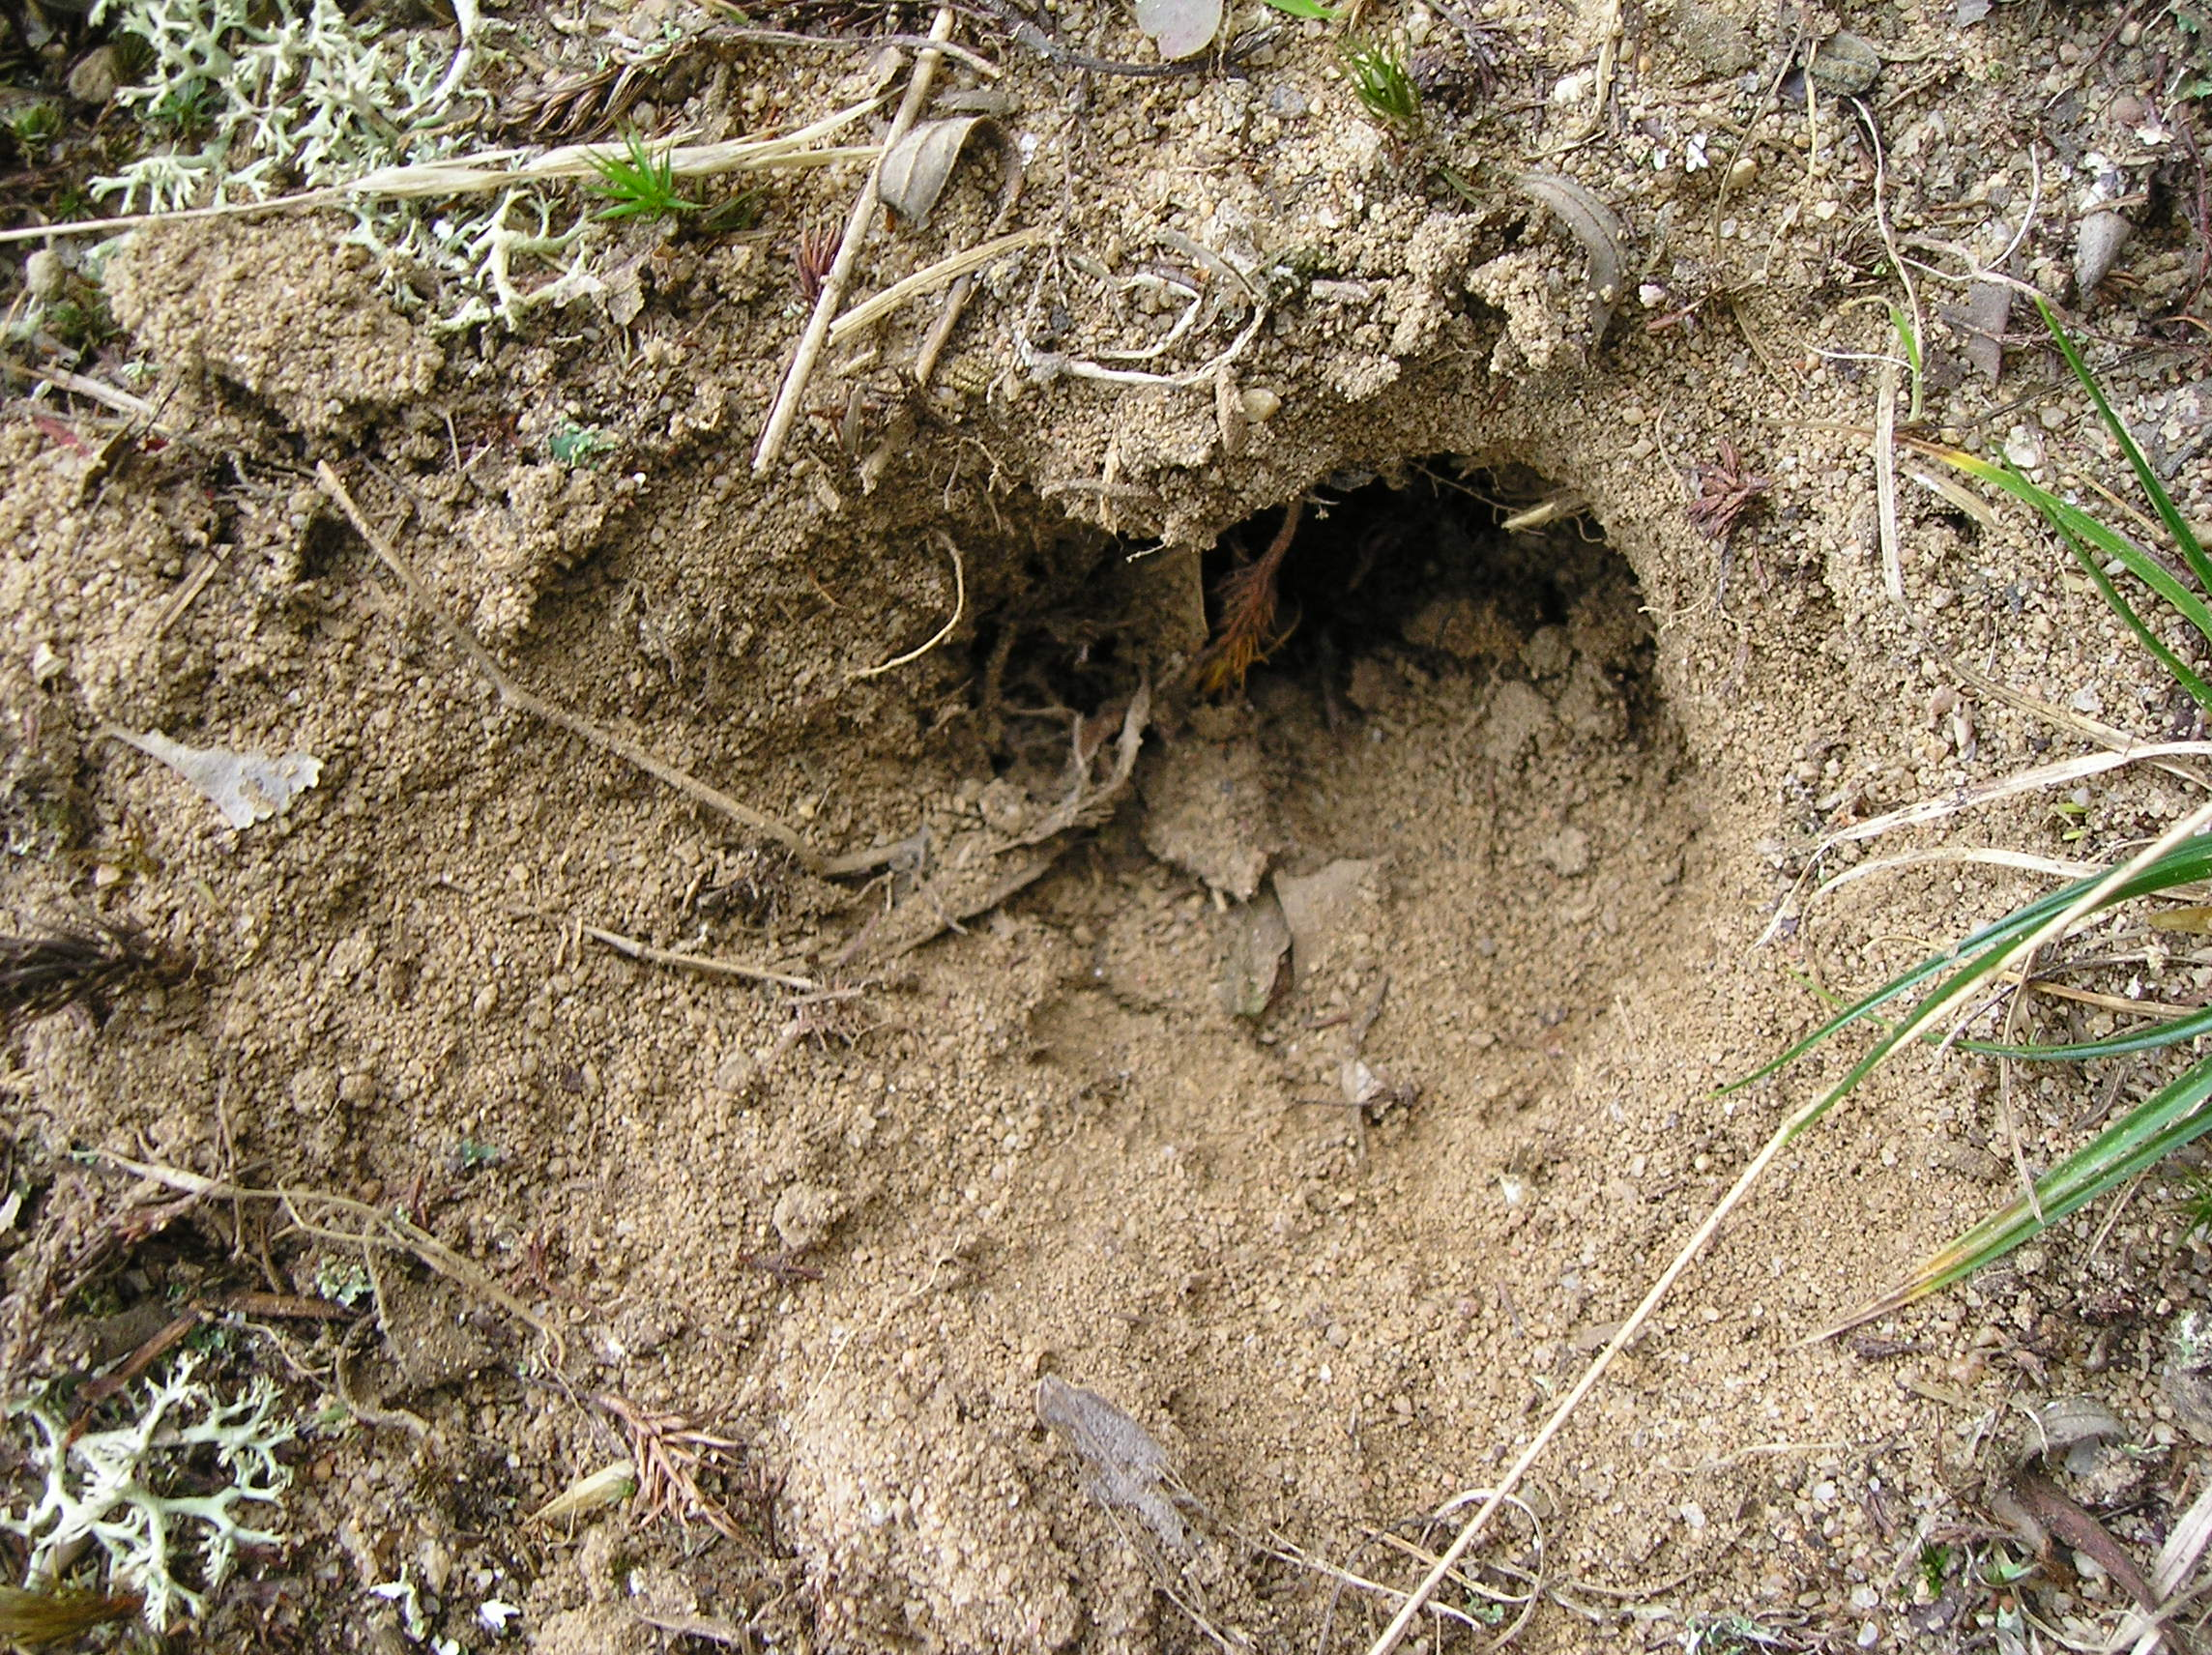
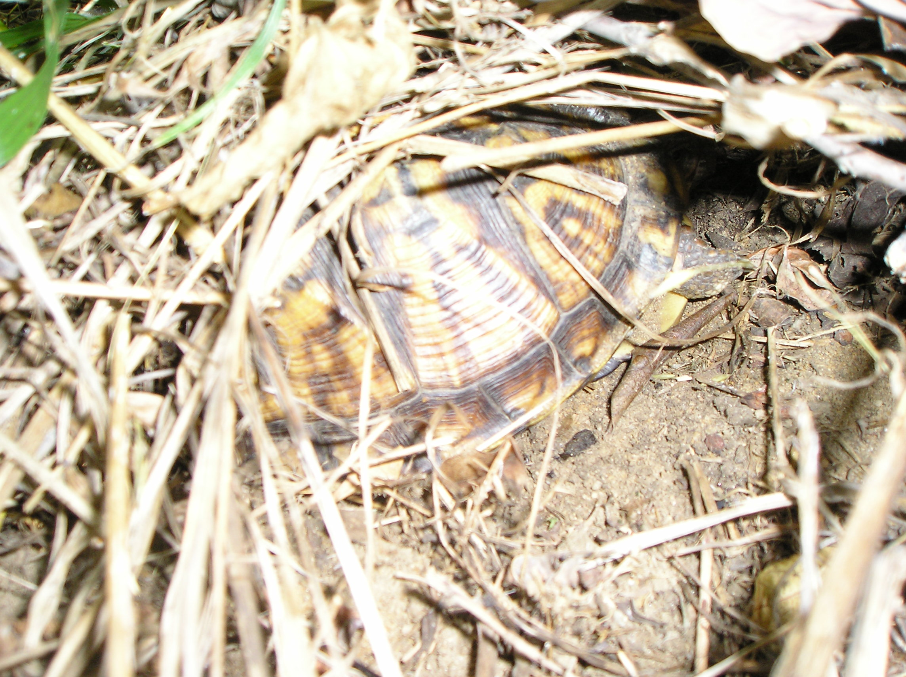

Turtle Nest Overwintering Turtle

In this part of the activity, you will use the Data Mapper to collect information about the areas where the turtle nests are.
Local Environments: Collect Data

- Double-click on the study area symbol to get a small-scale view. You may have to double-click twice to get the tool to work. The screen will look like this:

- The box symbols () show where we put macroscope motes next to turtle nests in this field research site. Hover your mouse over one of the motes to see what its ID is and what types of sensors it has.

- Zoom out to see where all the motes are located in the study area. The map below shows where each mote is located. Zoom in and out on each mote until you can clearly see the environmental setting of each mote. Scientists refer to this environmental setting as the mote’s local environment.
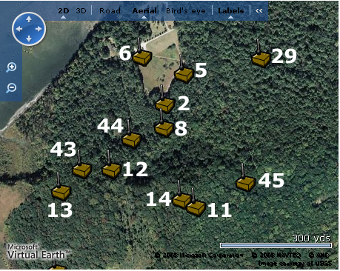

Local Environments: Analyze Data

- In this activity, you will focus on the turtle nests, in motes 2, 5, and 6. What local environment is each of these motes in?

- Which motes have the most similar and different environments?

Local Environments: Interpret Data

- Which motes would you expect to have the warmest average soil temperature? The coolest? Which would have the soil temperature that varied the most? The least?

- How are motes 2, 5, and 6 similar and different? What implications might this have for the

Part III
Understanding Changes in Time

We left our macroscope at our field research site in Jug Bay for several months. The data that each mote collected during that time was automatically recorded and stored in a database. One of the pieces of data that we are most interested in is the soil temperature. We measure soil temperature at two depths at each mote – at the top and bottom of each turtle nest or overwintering turtle.

In this activity, you will use those soil temperatures to examine cycles in the soil environment.

Changes in Time: Collect Data

- First, open a new browser window. Go to Life Under Your Feet and click on Deployments. Scroll down to “Jug Bay” and read about the sensor deployment at Jug Bay. What are the start and end dates of the sensor network deployment? Write down the dates below so you can use them to collect the data.

- Click on mote 5 to highlight it. Click next.
- Select Soil Temperature by checking the boxes next to the “Soil Temperature (second-generation sensors)” label.
- To select the start date for the graph, click the “…” label next to Start Date box (under the “Start and End Dates for plot” label). A calendar will pop up.
- Use the calendar to select September 1, 2007 for the start date.
- Similarly, using the calendar for the End Date, select January 1, 2008 for the end date.
- Select 4 hours for the timestep.
- Select Line Only.
- Click Submit.

- You will see a graph of the soil temperature, as measured by the soil temperature sensor on mote 5 of our macroscope, between 9/1/2007 and 1/1/2008. The red line represents the soil temperature at the top of the turtle nest and the blue line represents the temperature at the bottom of the turtle nest. You can make the graph larger in the x direction by clicking the blue arrow or in the y direction by clicking the green arrow. The graph will look like this:
- Similarly, create a graph of soil temperature for mote 6, for the same period. Sketch the graph that you see in the space below. Label the axes.

Changes in Time: Analyze Data

- You can see both short-term and long-term cycles on both graphs. How much time do these cycles take, both the short-term and the long-term?

- Compare and contrast the soil temperature measurements at the top and the bottom of the turtle nest for mote 5 (sensors 93 and 94). Do the same for mote 6 (sensors 103 and 104). What similarities and differences do you see between two depths at the same turtle nest?

- Compare and contrast the soil temperature measurements for mote 2 and mote 6. What similarities and differences do you see between the two turtle nests?

Changes in Time: Interpret Data

- What is the cause of the two types of cycles that you see in the data?

- Which mote has bigger changes in soil temperature at either depth? Was this what you expected?

- Are there larger changes in soil temperature at the top of the turtle nest or at the bottom? Why do you think this might be the case?

- What advantage is it to turtles to lay their eggs in these areas?

Extend

- Make another graph of soil temperature for two of the motes where the overwintering are. What do you notice about the places where turtles spend the winter?

